

SUREKEY EXAMINATIONS BOARD

**PRIMARY FIVE QUALITY CHECK ONE EXAMINATION**

2024

SOCIAL STUDIES WITH RELIGIOUS EDUCATION

***Time Allowed: 2 hours 15 minutes***

**School Admission No. Personal No.**

**Pupil’s Name:** ……………………………………..………………………..………………………..

**Pupil’s Signature:** …………………………………………………………..……………………….

**School Name:** …………………………………………………………………………………………..

**District Name:** …………………………………………………………………………………………

**Read the following instructions carefully:**

**FOR EXAMINERS’**

**USE ONLY**

**Qn. No. MARKS EXR’S**

**NO.**

1 – 10

11 − 20

21 – 30

31 – 40

41 – 43

44 – 46

47 – 49

50 – 52

53 – 55

**TOTAL**

1. Do not forget to write your **school** or

**district name** on the paper.

1. This paper has two sections: **A** and **B**. Section **A** has **40** questions and section **B** has **15** questions. The paper has **12** printed

pages.

1. Answer **all** questions. **All** working for both sections **A** and **B** must be shown

in the spaces provided.

1. **All** answers **must** be written using a **blue**

or **black** ball point pen or ink. Any work

written in pencil will **not** be marked.

1. Unnecessary **changes** in your work and handwriting that cannot be read

easily may lead to **loss of marks**.

1. Do not fill anything in the table indicated:

**“For Examiners’ use only”** and boxes

inside the question paper.

***©*** *2024 Surekey Examinations Board 0700758668* **Turn Over**

**SECTION A: 40 MARKS**

Questions **1** to **40** carry **one mark** each

1. Mention any **one** material people use to build semi-permanent houses.

………………………………………………………………….………………………………….….…

1. Write any **one** quality a good head boy at school should have.

…………………………………………………………………………………………………….……..

1. State any **one** danger caused by too much sunshine in the environment.

…………………………………………………….……………………………………………………..

1. Why is water regarded as a basic need?

………………………………………………………………….……………………………….…….…

1. Name the component of the environment which is a source of solar energy.

…………………………………………………………………………………………………………….

1. State any **one** way people benefit in the nearby market within their locality

……………………………………………………………………………………………………….…..

1. Give any **one** reason why a school should fence its boundaries.

………………………………………………………………………………………………………......

1. Name the important place where the map symbol below is found.

…………………………………………………………………………………………………………….

1. Mention any **one** crop that grows well in swampy areas.

……………………………………………………………………………..………………………….…

1. How was Gipir related to Olum according to the legend of the spear and the

Bead?

………………………………………………………………………………………………..….….…

**2**

1. State any **one** way how the people of long ago preserved fish.

………………..…………………………………………………………………….……………………

1. In which **one** way is brick making an important activity for people in our

communities? ……………………………………………………………………………..…………………………….

1. State any **one** role of children in promoting peace and security.

…………………………………………………………………………………………………..………

1. Name the first hospital to be built in Uganda.

…………………………………………………………………………………………….…………….

1. Who is a child according to the laws of Uganda?

……………………………………………………………………………………………………………

1. Mention any **one** activity commonly done by people during wet season.

……………………………………………………………………………………………………………

1. What form of trade is practiced when you exchange sugarcane for a

jack fruit?

…………………………………………………………………………….…………………………..

1. Mention any **one** example of non-traditional cash crop.

…………………………………………………………………………………………………………

1. Give any **one** example of volcanic mountain in Uganda.

…………………………………………………………………………………………………………

1. State any **one** reason why schools plant trees in their compound.

…………………………………………………………………………………………………………

1. Why is a nurse an important person in our community?

…………………………………………………………………………………………………………

1. Write **one** government programme that was introduced to provide free

education in Uganda.

…………………………………………………………………………………………………………

1. State any **one** way how fire was important to the early man.

…………………………………………………………………………………………………………

**3 Turn Over**

1. 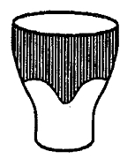Give **one** challenge of the mean of communication below.

………………………………………………………………………………………………..………….

1. Write any **one** danger caused by potholes in major roads in your district.

……………………………………………………………………………………….…………………..

1. How is a compass important to mountain climbers?

…………………………………………………………………………………….……………………..

1. Write the full form of **DDHS.**

……………………………………………………………………………………….……………………

1. Give any **one** way of locating places in your district.

……………………………………………………………….……………………………………………

1. Mention any **one** common crime committed in our society today.

…………………………………………………………………………………………………………...

1. Jaliah was going to the mosque in the morning and she saw her shadow in

front of her. In which direction was the mosque?

………………………………………………………………………………………….………………..

1. State any **one** responsibility of people in developing their district.

…………………………………………………………………………………………………………….

1. Write **one** disadvantage of traditional means of transport.

…………………………………………………………………………………………………………….

1. Give any **one** way through which the early people obtained food.

…………………………………………………………………………………………………………….

1. State any **one** role of children in promoting peace and security in a village.

………………………………………….…………………………………………………………………

**4**

1. Give any **one** reason why you would visit any national park in Uganda.

……………………………………………………………………………………………………….……

For each of the questions **36** to **40**, answer **Either** the Christian **OR** Islamic questions but **not** both. No **marks** will be awarded to a candidate who attempts both alternatives in **a particular number**.

1. **EITHER:**

Who is taken to be the leader of church according to Christian teaching?

…………………………………………………………………………………………………………….

**OR:**

What title is given to the supreme leader of Muslims in a country?

………………………………………………………………………………………………….………..

1. **EITHER:**

Mention any **one** thing which may spoil your relationship with a fellow

Christian.

……………………………………………………………………………………………….…………..

**OR:**

Mention any **one** thing which may spoil your relation with a fellow Muslim.

……………………………………………………………………………………………….…………..

1. **EITHER:**

Write the full form of **U.J.C.C.**

…………………………………………………………………………………………………………..

**OR:**

Write the full form of **U.M.S.C**

……………………………………………………………………………………………………………

1. **EITHER:**

Mention **one** punishment God gave to Eve for eating the fruit from the

forbidden tree.

……………………………………………………………………………………………………………

**5 Turn Over**

**OR:**

Mention **one** punishment Allah gave to Hawa for eating the fruit from the

forbidden tree.

……………………………………………………………………………………………..……………

1. **EITHER:**

Why was Noah asked to build the ark?

……………………………………………………………………………………………………………

**OR:**

Why was Prophet Nuhu asked to build the ark?

……………………………………………………………………………………………………………

**SECTION B: 60 MARKS**

Questions **41** to **55** carry four marks each.

1. (a) Give the meaning of the term vegetation.

…………………………………………………………………………………………………..

…………………………………………………………………………………………………..

(b) Write **one** human activity which;

1. promotes the growth of vegetation

…………………………………………………………………………………………

1. destroys vegetation.

………………………………………………………………………………………….

(c) State any **one** way of conserving the vegetation of your school.

…………………………………………………………………………………………………..

1. (a) In which **two** ways are the commercial banks important to people of

your district?

1. …………………………………………………………………………………………
2. …………………………………………………………………………………………

(b) Write any **two** examples of commercial banks operating in Uganda

1. …………………………………………………………………………………………
2. …………………………………………………………………………………………

**6**

1. The table below shows the people and the services they provide arranged in wrong order. Study the table and match the information correctly.

|  |  |
| --- | --- |
| **Person** | **Services** |
| 1. Nurses 2. Sailors 3. Police officers 4. Plumbers | * Installation of piped water * Medical care * Transport * security |

1. Nurses: ……………………………….……….………………………………………
2. Sailors: ………………………………………….…………………………………….
3. Police officers: ………………………………………………………………………….
4. Plumbers: ………………………………………………………………………………..
5. (a) What term is used to mean the violation of children’s rights?

…………………………………………………………………………………………………

(b) Write any **two** examples of freedoms children in your district are

entitled to.

1. ……………………………………………………………………….………………….
2. …………………………………………………………………………………………..

(c) Give **one** way how the government of Uganda can protect children

against the violation of their rights.

…………………..……………………………………….…………………………………….

1. (a) Mention any **two** examples of recreation activities people do in your

community.

1. ………………………………………………………………….………………………
2. ………………………………………………….………………………………………
3. In which **two** ways are recreation activities important to people?
4. …………………….……………………………………………………………………
5. ………………………………………………………………………………………….

**7 Turn Over**

1. Study the sketch map of Uganda below and use it to answer the questions that follow.

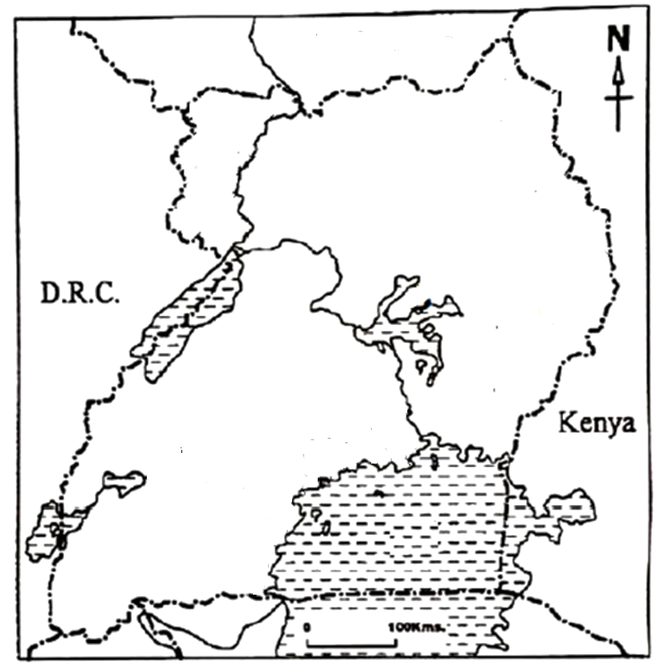

**C**

**00**

**00**

**N**

1. Name the line of latitude marked Oº on the map.

…………………………………………………………………………………………..……...

1. What is the direction of Uganda from DRC?

…………………………………………………………………………………………..……...

1. Name Uganda’s neighbour marked **C**.

…………………………………………………………………………………………….…....

1. State any **one** waylake marked **N** promotes the development of

Uganda.

……………………………………………………………………………………….………….

1. (a) What is trade?

………………………………………………………………………….……………………….

…………………………………………………………………………….…………………….

(b) Give any **two** problems affecting traders in your district.

1. ……………………………………………………………………………………………
2. ……………………………………………………………………………………………

**8**

(c) Write any **one** solution to problems facing traders at their work

places.

……………………………………………………………………………………………………

1. The diagram below shows two ethnic groups. Study it and answer the questions that follow.

ETHNIC GROUP

**A**

Bantu

**B**

Karimajongs

**C**

Cultivation

(a) Write any **one** tribe you would place at **B**.

………………………………………………………………….………………………………

1. Name the ethnic group marked **A**.

…………………………………………………………..………………………………………

1. Which economic activity marked **C** is done by the Karimajongs?

…………………………………………………………………………………………………..

1. Give any **one** cause of the early migration of the tribal groups.

……………………………………………………………………………………….………….

1. (a) Mention any **two** materials the Early man used for making his tools.
2. ……………………………………………………………………………………………..
3. ……………………………………………………………………………………………..

(b) How did the Early man use the bolas to live a better life?

……………………………………………………………………………………………….…..

(c) Give **one** reason why the discovery of fire was important to the

Early man.

……………………………………………………………………………………………………

**9 Turn Over**

1. (a) Give any **two** reasons why you think Uganda is divided into more

new districts.

1. ……………………………………………………………………………………………
2. …………………………………………………………………………………….……..
3. State any **one** problem the people in highland districts of Uganda face.

……………………………………………………….………………………….………………

1. Give **one** reason why the people of Moroto district rear donkeys.

……………………..……………………………………………………………………………

For each of the questions **51** to **55**, answer **EITHER** the Christian **OR** Islamic questions but **not** both. **No mark** will be awarded to a candidate who attempts

both alternatives in **a particular number**.

1. **EITHER:**
2. On which day was Jesus’ promise of the Holy Spirit to his apostles

fulfilled?

…………………………………………………………………………………………………..

1. Write **two** symbols of the Holy Spirit.
2. ……..…..………………………………………………………………………………..
3. ……………………………………………………………………………………………
4. In which **one** way is the Holy Spirit important in the life of Christians?

….….………………………………………………………………………………………….

**OR:**

1. Write any **two** pillars of Islamic faith.
2. ……………………………………………………………………………………………
3. …………………………………………………………………………………………..
4. In which **two** ways do Muslims observe the pillars of Islamic faith in

their lives?

1. ……..…..………………………………………………………………………………
2. …………………………………………………………………………………………..
3. **EITHER:**
4. Name the Sacrament in Christianity performed using bread and wine.

…………………………………………………………..…………………………………..…

1. According to the above sacrament what do the following represent?
2. Bread: …………………………………….…………………………………..……
3. Wine: ………………………………………………………………………..…….

**10**

1. Mention **one** condition one must fulfil before receiving the sacrament

named in (a) above.

…………………………………………………………………………………………………..

**OR:**

1. Give the meaning of the terms below;
2. Hijab: ……………………………………………..…………..……………………
3. Hijjah: ………………………………………………………………………………
4. Give any **one** reason why a Muslim woman should put on Hijab.

…………………………………………………………………….…………………………..

1. Name the city in Islam where Muslims perform Hijjah from.

………………………………………………………………………………….……………..

1. **FOR BOTH:**
2. Give any **two** ways through which you can serve the elderly people

in your community.

1. …………………………………………..………………………………………………
2. …………………………………………………………………………………………..
3. Mention any **two** benefits one gets from helping the elderly people

in the community.

1. …………………………………………………………………………………………
2. …………………………………………………………………………………………
3. **EITHER:**
4. Who is Martyr?

…………………………………………………………………………………………………

1. Name the Christian Martyr in the Bible who was stoned to death.

…………………………………………………………………………………………………

1. Write any **two** important lessons you learn from the life of the

Christian Martyrs.

1. ……………………………………………………………………………………………
2. ……………………………………………………………………………………………

**11 Turn Over**

**OR:**

1. Who is a Martyr?

…….…………………………………………………………………………………………..

1. Name the first Muslim Martyr according to Islam.

…………………………………………………………………………………………………

1. Write any **two** important lesson you learn from the life of Muslim

Martyrs.

1. …….…………………………………………………………………………………….
2. ……..……………………………………………………………………………………
3. **EITHER:**

“For God love the world so much that He gave His only son, so that everyone who believes in Him may not die but have eternal life.”

**(John. 3 :16)**

1. Name the son who is being referred to in the above quotation.

…………………………………………………………………………………………………

1. Why did God send His son to this world?

…………………………………………………………………………………………….…..

1. Write any **two** good acts which will enable Christians to acquire

eternal life.

1. ……………………………………………………………………………………………
2. …………………………………………………………………………………………...

**OR:**

“Indeed, the righteous (those who do good acts) will be in a secure place……….He will have protected them from the punishment of hell fire.”

**(Qur’an 44:51-56)**

1. Name the secure place where the righteous people will be.

…………………………………………………………………………………………………

1. Which group of people will be punished with hell fire?

………………………………………………………………………………………………….

1. Write any **two** good acts which will enable Muslims to acquire the

secure place in (a) above.

1. …………..………………………………………………………………………………
2. …………….…………………………………………………………………………...

**12 END**